MPayz UI

# Landing Page

This is the landing page, which provides you with 2 options, either to create a new wallet or login with existing wallet.

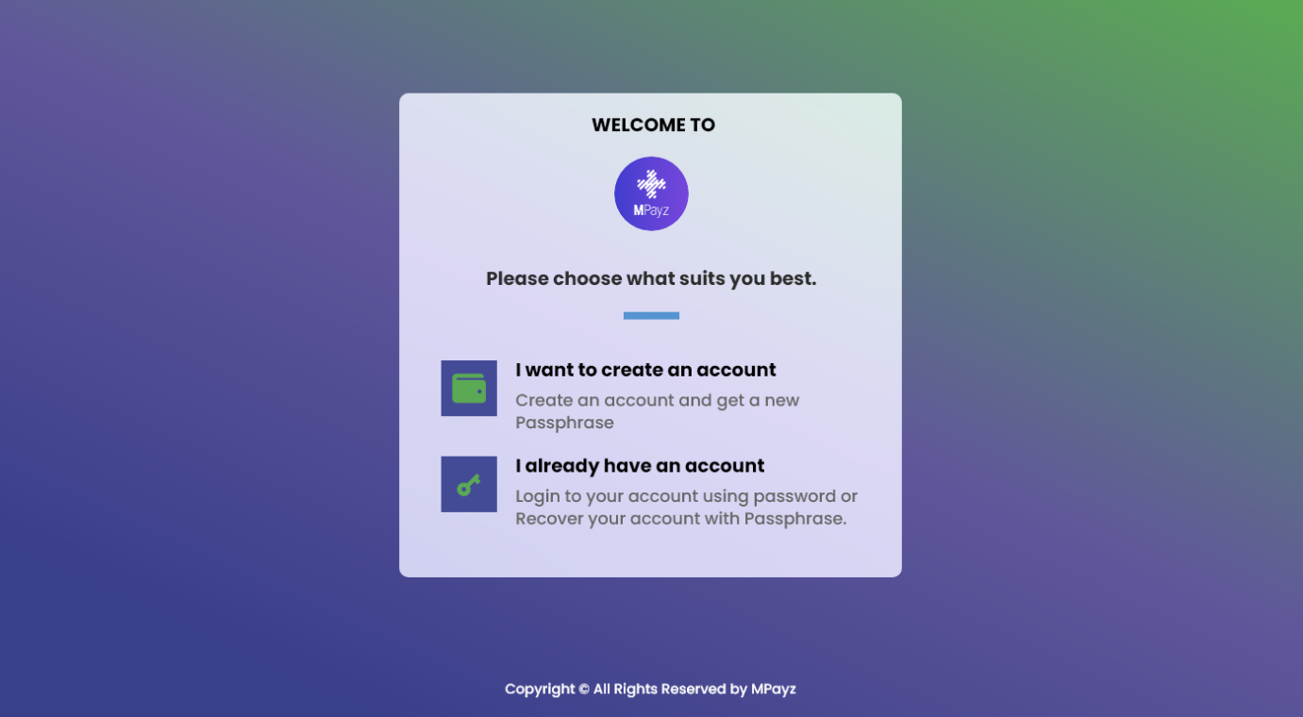

|  |  |
| --- | --- |
| Add/Edit: | Welcome to MPayz |
|  | Select Option Below. |
|  | Create a new account  Create an account and get a new passphrase |
| Comment: Use Log In as 2 words only on this page. The other sections can keep Login. | Returning user?  Log In to your account using your password or recover your account with your passphrase |

# Passphrase POP-UP

This pop-up will alarm user to save user’s passphrase, and let user know the importance of passphrase

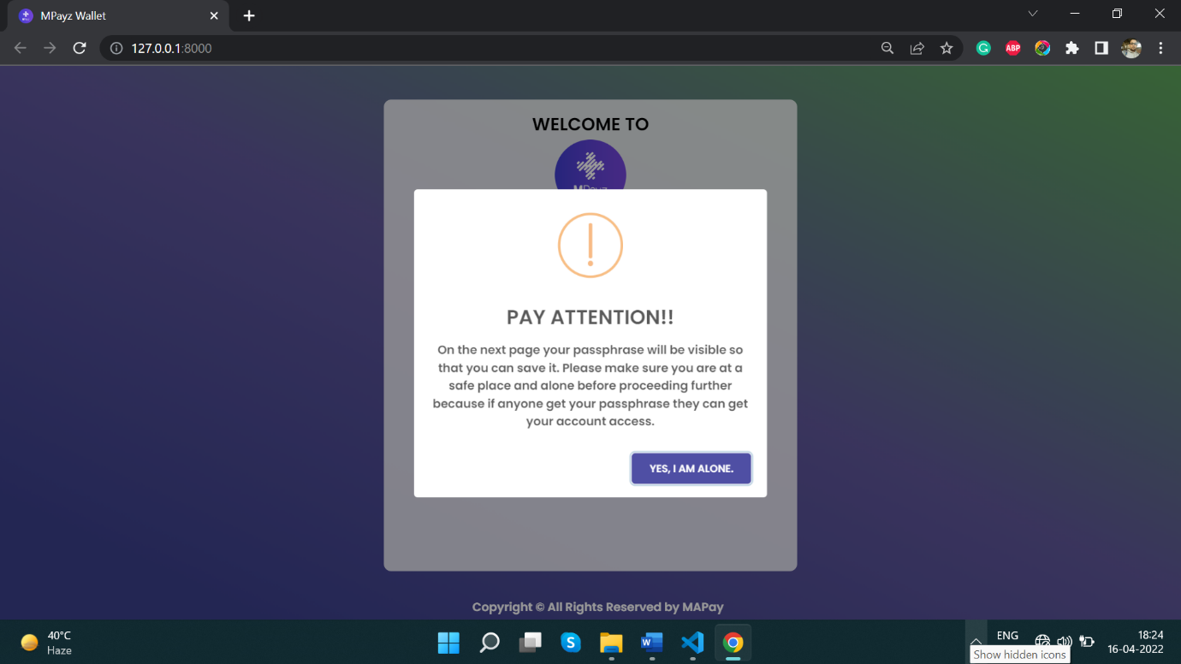

|  |  |
| --- | --- |
| Edit: | Attention! |
|  | Your passphrase will display on the next page. Use caution when viewing in public spaces. Save and guard the entire 25-word passphrase to prevent unauthorized access to your account. Account recovery will require all passphrase words. |
| Button | Confirm |
|  |  |

# Create Passphrase

Once the user confirms that user understands the significance of the password, the user will be presented with a 25-word long Algorand.

User can regenerate the passphrase as well.

The user can directly copy the passphrase to the clipboard.

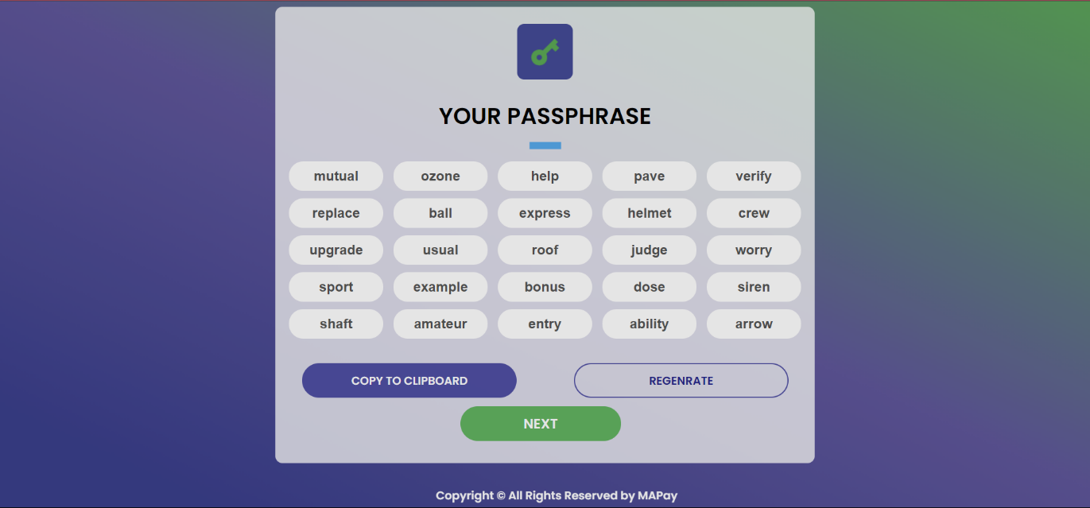

|  |  |
| --- | --- |
| If possible, add this message again: | Save passphrase. Account recovery will require all passphrase words. |
|  |  |
|  |  |
|  |  |

# Verify Passphrase

Once the user has saved the passphrase, user can click next. User will next have to select 5 words from the randomly generated words, to confirm the identity.

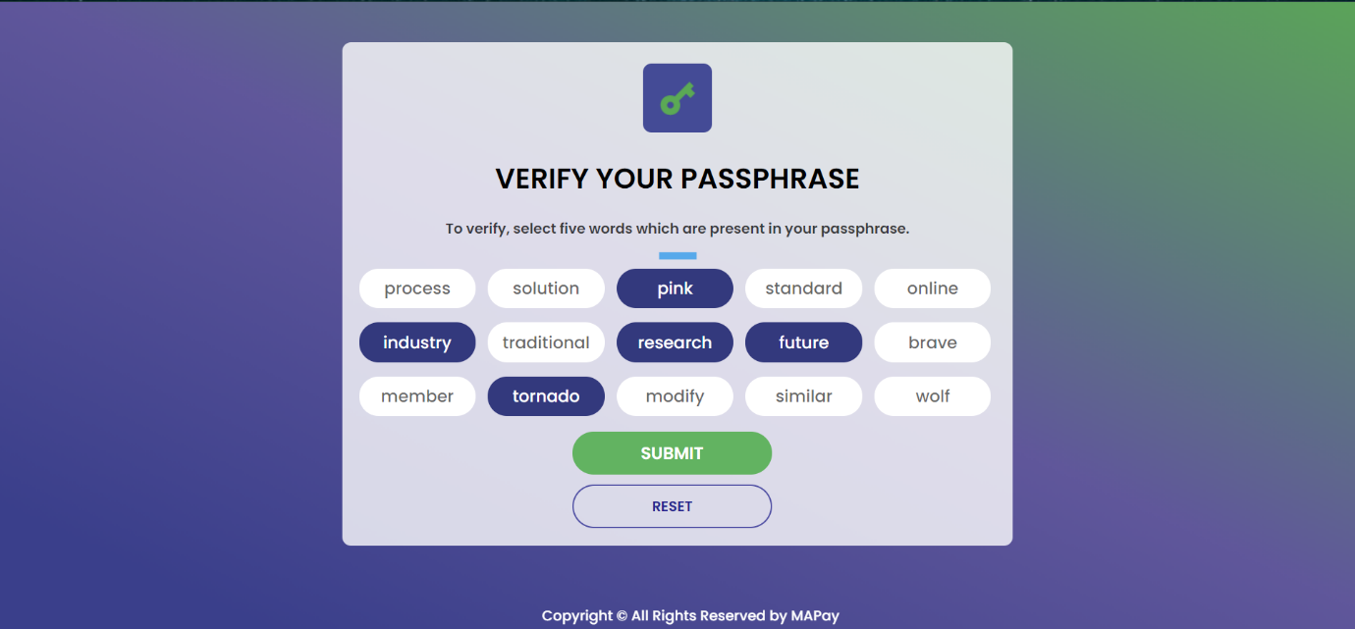

|  |  |
| --- | --- |
| Edit: | To verify, select five words which appear in your passphrase. |
|  |  |
|  |  |
|  |  |

# Login Screen

If the user has successfully created MPaz account and wishes to login, the user must provide user login credentials before being sent to the dashboard.

If by any way the user forgot user login credentials, user can click on “Recover account”.

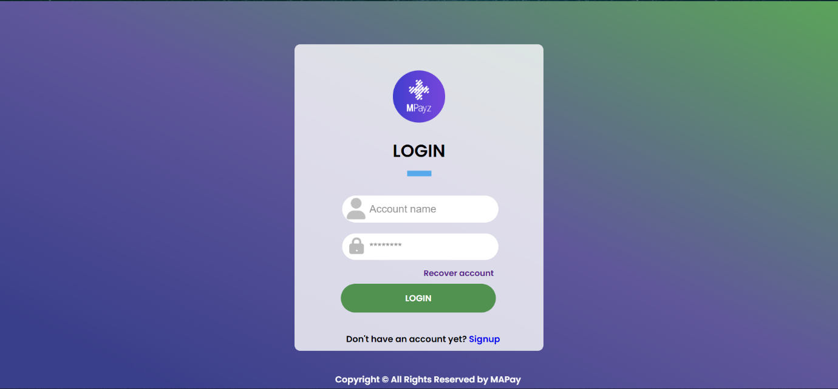

|  |  |
| --- | --- |
| Edit: | Sign Up |
| Question: Should this say “…All Rights Reserved by MPayz” ? |  |
| Question: Is this an Account Name or Username? |  |
|  |  |

# Recover Account

If a user wants to recover user account, then user need to manually type in each and every passphrase word.

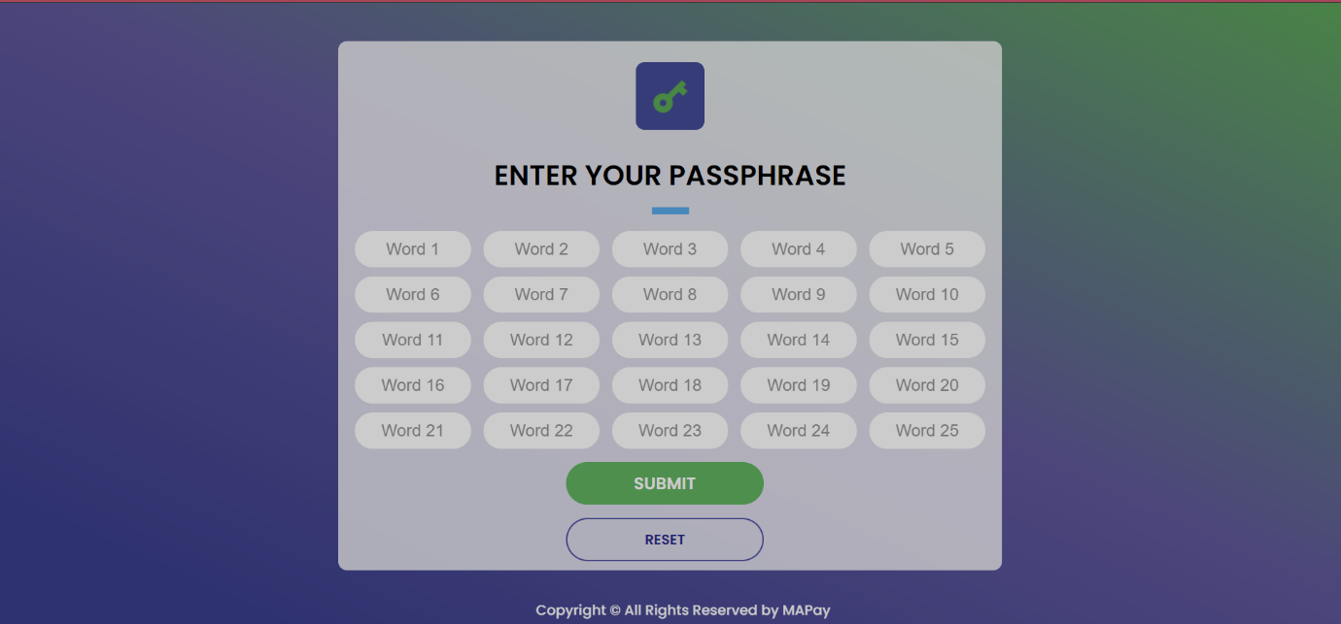

|  |  |
| --- | --- |
|  |  |
|  |  |
|  |  |
|  |  |

Dashboard

Once the user successfully logins, user will be redirected to the dashboard, where all the details are provided.

User can select between Testnet and Mainnet.

Notifications will contain all the messages, payments requests, etc.

Message will be a service where a user can chat with support or other user(s).

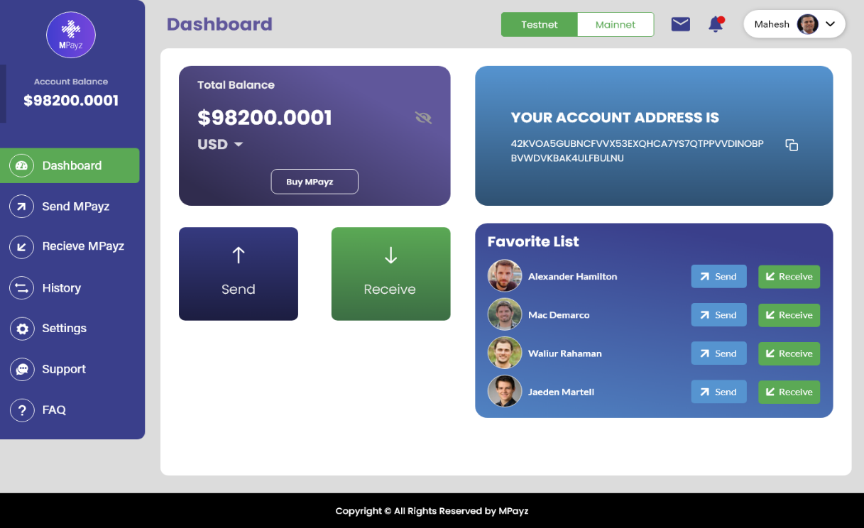

|  |  |
| --- | --- |
| Edit: | Favorites |
|  | FAQs |
| Spelling: | Receive MPayz |
|  |  |

Send

If a user wants to send some MPayz, user can go to here, enter the required details.

We have provided an option of sending to favourite contact; hence user don’t need to enter address.

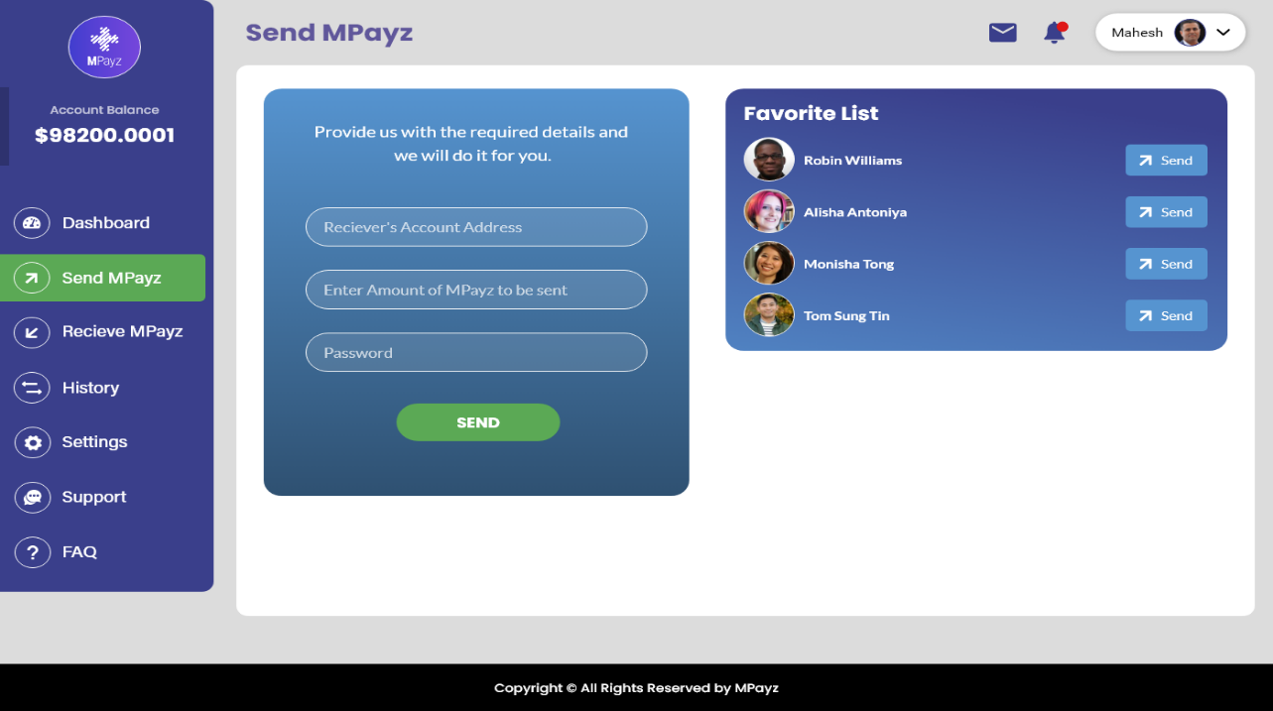

|  |  |
| --- | --- |
| Edit: | FAQs |
|  | Enter details below. |
|  | Recipient’s Account Address |
|  | Favorites |
| Question: Is this just a whole number? Or decimal? What is format? | Enter Amount of MPayz to Send |
| Spelling: | Receive MPayz |

Receive

If user wants to request MPaz or raise some bills, user can do that using the receive form.

User can copy user address using the copy icon or can scan the bar code.

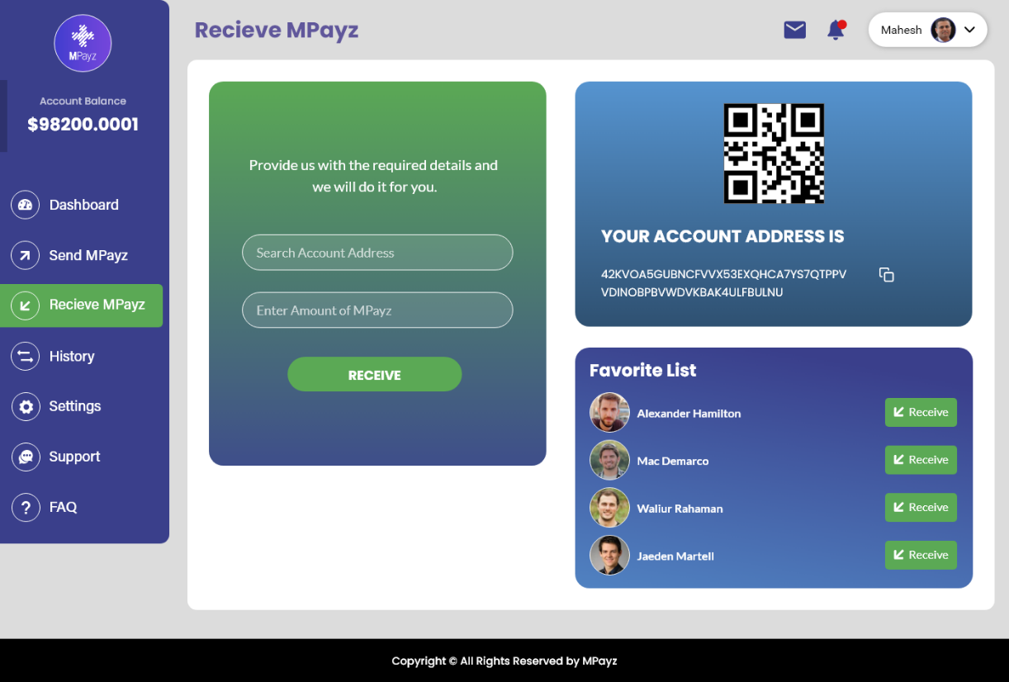

|  |  |
| --- | --- |
| Edits/Spelling: | Receive MPayz |
| Question: Is this just a whole number? Or decimal? What is format? | Enter details below. |
| Button/Spelling: | Receive |
|  |  |

History

User can get all the details of user transactions here.

User can search for a transaction based on the transaction ID.

Transactions can be sorted based on transaction type.

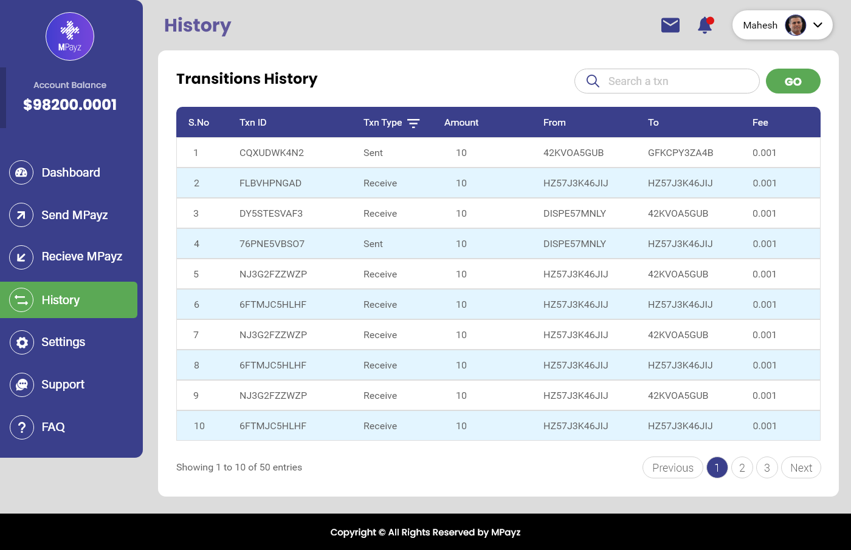

|  |  |
| --- | --- |
| Spelling: | Transaction History |
|  |  |
|  |  |
|  |  |

FAQ’s

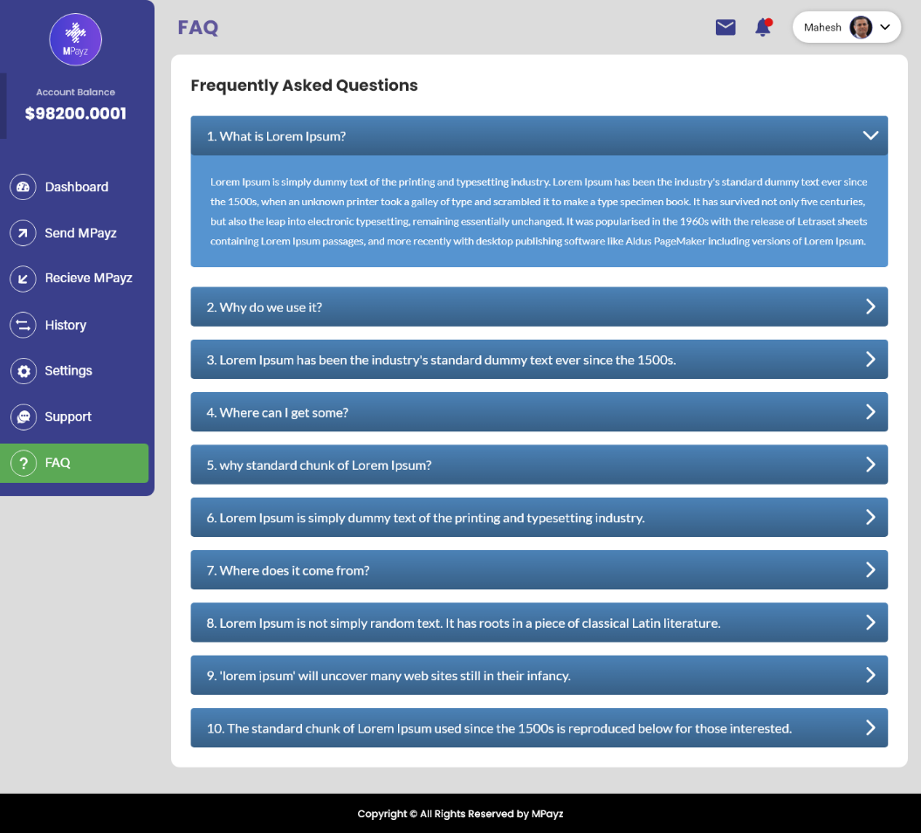

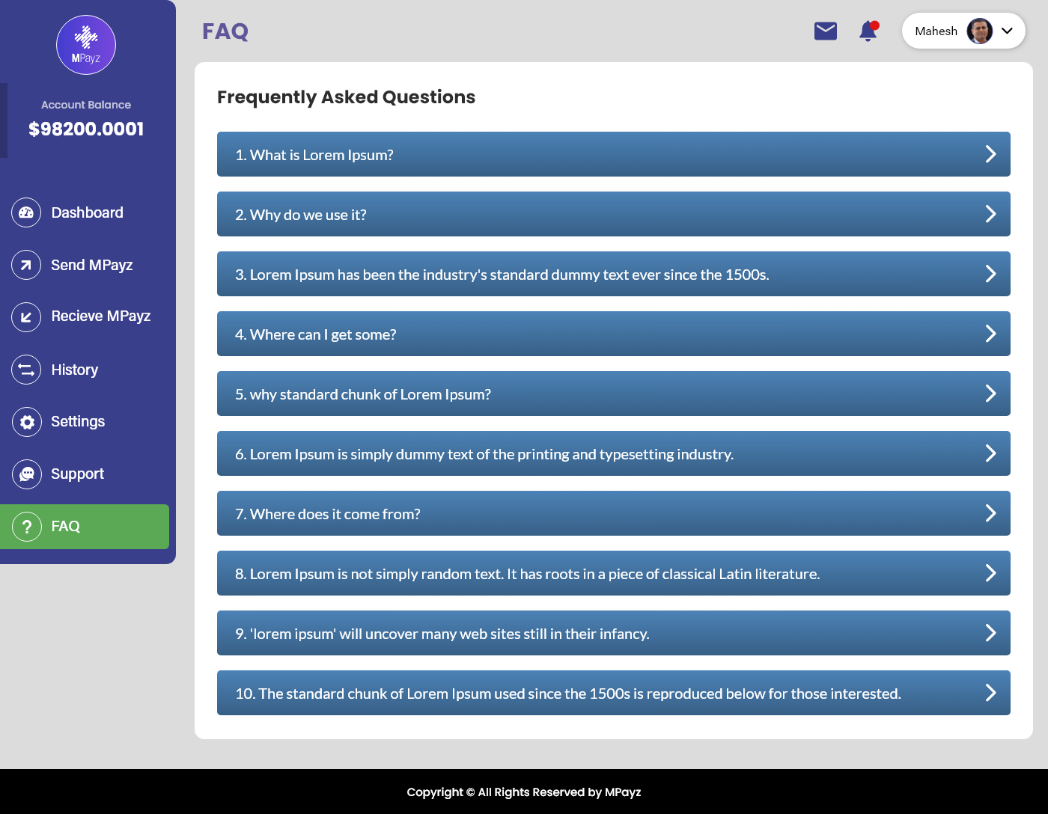

|  |  |
| --- | --- |
| FAQs to be determined. | FAQs |
|  |  |
|  |  |
|  |  |

# Support

A user can contact the support, by raising a ticker or though the contact information provided.

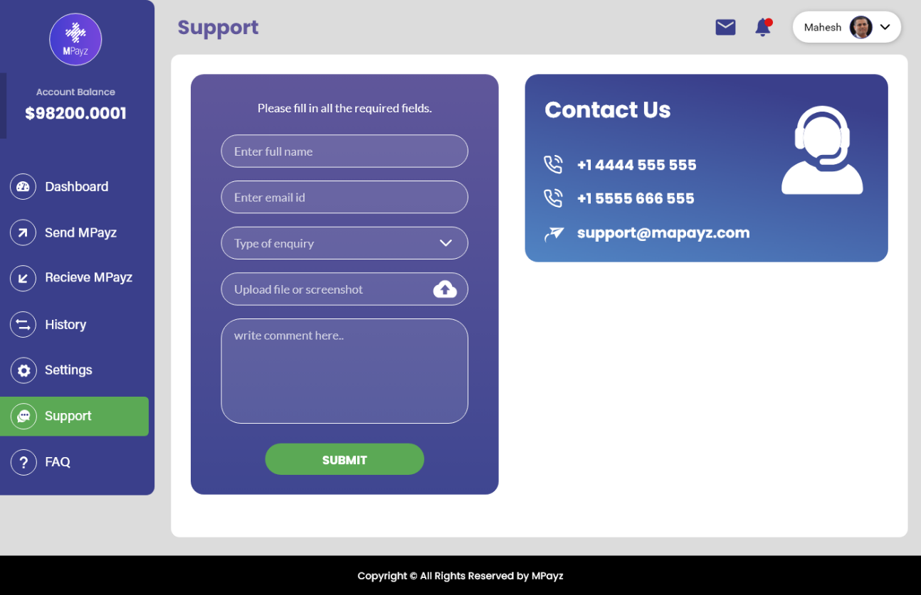

|  |  |
| --- | --- |
| Edits: | Please enter all required fields. |
|  | Enter email |
| Question: Is this a dropdown? | Type of Inquiry |
|  | Enter comments |
| Contact us info to be determined |  |

Settings

Under setting you can change and edit your profile details.



    
    
    
    
    
    